

Capstone Project Report
Report 2 – Project Management Plan

– Ho Chi Minh, December 2024 –
Table of Contents
I. Record of Changes 3
II. Project Management Plan 4
1. Overview 4
1.1 Scope & Estimation 4
1.2 Project Objectives 6
1.3 Project Risks 6
2. Management Approach 6
2.1 Project Process 6
2.2 Quality Management 7
2.3 Training Plan 8
3. Responsibility Assignments 8
4. Project Communications 8
5. Configuration Management 9
5.1 Document Management 9
5.2 Source Code Management 9
5.3 Tools & Infrastructures 9

I. Record of Changes
Date | A*  M, D | In charge | Change Description
23/09/2024 | A | All Members | Add Scope & Estimation.
25/09/2024 | A | QuocLNH | Add Project Process, Training Plan.
25/09/2024 | A | HieuNM | Add Project Risks, .Net Coding Conventions.
25/09/2024 | A | NgocPD | Add React and Flutter Coding Conventions, Responsibility Assignments.
25/09/2024 | A | ThaoHTP | Add Project Communication, Configuration Management
27/11/2024 | M | QuocLNH | Update Scope & Estimation, Management Approach, Responsibility Assignments and Tools & Infrastructures.
10/12/2024 | M | QuocLNH | Update Scope & Estimation, Project Objectives.
*A - Added M - Modified D - Deleted

II. Project Management Plan

1. Overview

1.1 Scope & Estimation
# | WBS Item | Complexity |  | Est. Effort  (man-days)
1 | Requirement analysis |  |  | 7
1.1 | Analyze the context and background of the product | Medium |  | 1
1.2 | Research and analyze existed system | Simple |  | 1
1.3 | Define the user requirement and business process | Complex |  | 3
1.4 | Analyze the business opportunity | Medium |  | 2
2 | Technical Learning |  |  | 14
2.1 | Learn CI/CD tool and third-party | Medium |  | 14
3 | Design database |  |  | 6
3.1 | Design concept model | Medium |  | 3
3.2 | Design logical model (ERD) | Medium |  | 2
3.3 | Design physic model (Database) | Medium |  | 1
4 | Document writing |  |  | 26
4.1 | Project Introduction Report | Medium |  | 2
4.2 | Project Management Plan Report | Medium |  | 3
4.3 | Software Requirement Specification Report | Complex |  | 5
4.4 | Software Design Document Report | Complex |  | 5
4.5 | Test Document Report | Complex |  | 7
4.6 | Software User Guide Report | Simple |  | 1
4.7 | Final Project Report | Medium |  | 3
5 | Client User Interface Design |  |  | 10
5.1 | Design web UI | Complex |  | 10
6 | Implement User Interface |  |  | 20
6.1 | Implement web UI | Complex |  | 20
7 | Implement Administrator Features |  |  | 12
7.1 | Manage user feature | Medium |  | 2
7.2 | Manage platform feature |  |  | -
7.2.1 | Manage subscription pack feature | Medium |  | 2
7.2.2 | Manage feature pack feature | Medium |  | 2
7.3 | Manage platform transaction feature | Medium |  | 2
7.4 | Manage support ticket feature | Medium |  | 2
7.5 | Validate feedback feature | Medium |  | 3
8 | Implement Client Features |  |  | 29
8.1 | Authentication/Authorization features | Medium |  | 2
8.2 | Manage business information feature |  |  | -
8.2.1 | Manage promotion features | Medium |  | 2
8.2.2 | Manage subscription features | Medium |  | 2
8.2.3 | Manage service features | Medium |  | 2
8.3 | Manage order features | Medium |  | 2
8.4 | Manage feedback features | Medium |  | 2
8.5 | Manage account’s information features | Simple |  | 1
8.6 | Manage cart feature | Medium |  | 2
8.7 | Manage payment feature | Complex |  | 7
8.8 | Chatting | Complex |  | 7
9 | Deploy System |  |  | 4
9.1 | Deploy front-end | Medium |  | 2
9.2 | Deploy back-end | Medium |  | 2
10 | Testing |  |  | 15
10.1 | Unit test | Medium |  | 3
10.2 | Integration Test | Complex |  | 5
10.3 | System test | Complex |  | 7
11 | Improvement | - |  | 14
11.1 | Fixing Bugs | Medium |  | 7
11.2 | Implement Addition Features | Medium |  | 7
12 | Closing |  |  | 10
11.1 | Maintaining | Medium |  | 7
11.2 | Prepare slide for thesis defence | Medium |  | 3
Total Estimated Effort (man-days) |  |  | 163

1.2 Project Objectives
# | Testing Stage | No. of Defects | % of Defect | Notes
1 | Unit Test | <10 | 10%
2 | Integration Test | <20 | 30%
3 | System Test | <15 | 15%

1.3 Project Risks
# | Risk Description | Impact | Possibility | Response Plans
1 | The team identifies too many features or requirements at the start, making the project too large to complete within time and resource limits. | High | Low | Discuss with mentor about the scope of the topic
2 | Failing to prioritize tasks lead us to inefficient use of time and resources, where critical tasks may be delayed, while less important tasks consume valuable resources. | High | Medium | Regularly review and adjust task priorities as the project progresses.
3 | Delays in task completion or unexpected issues can cause the project to fall behind schedule, potentially missing critical deadlines. | High | High | Forecast factors that could cause delays and create plans to address them before they become major issues.

2. Management Approach

2.1 Project Process
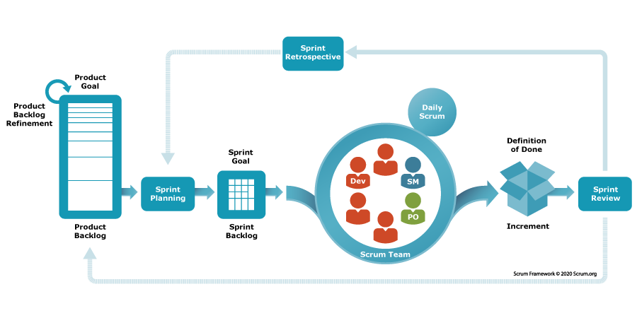
Scrum Framework Process Picture
The TP4SCS project is implemented by using the Scrum framework, the software development process model base on the Agile methodology due to several advantages reasons:
- First, because of being reviewed and feedback frequently by mentor and council, the requirement of the project will be changed continuously. So that the flexibility and adaptability characteristic of Scrum model will help the team to change goals or product requirements in the development process easily.
- Second, this is a large-scale project contain many complex and hard task to do. By break down and focus on small part makes it easier for the team to handle and fix errors early, which lead to the quality increment of the final release.
- Last, project have to review frequently and require done in a specified time, which require a continuously performance of the team. Because of this, the team need to meetings regularly to create a clear working process and stay informed.

2.2 Quality Management

2.2.1 .NET Coding Conventions
Convention of name:
- For the variable's name, use camelCase. Example: routeType, nextStation,etc.
- For function name, class name, use PascalCase. Example: GetAllStations, GetCurrentLocation, etc.
- Use meaningful names for variables.
- Avoid using Abbreviations. Example: use: UserGroup userGroup, do not use: UserGroup usrGrp
- Do use noun or noun phrases to name a class.
- Do prefix interfaces with the letter I.
Convention of layout:
- Write only one statement/declaration per line.
- Indent continuation one tab stop (four spaces).
- Add at least one blank line between method definitions and property definitions.
- Use parentheses to make clauses in an expression apparent.
Using C# Code Convention From: C# Convention

2.2.2 React Coding Conventions
Convention of name:
- Use PascalCase for React component names (ex: MyComponent.jsx).
- Use uppercase letters and underscores to assign constants. (ex: const MAX = 10; )
- Function and method names use camelCase
Convention of layout:
- Do not let a line be longer than 80 characters.
- Place the flow control statements in curly braces.
- Format code using React format
Using React Code Convention From: React Convention

2.3 Training Plan
Training Area | Participants | When, Duration | Waiver Criteria
Working Process | All Members | Week 1, 1 Days | Mandatory
GitHub | All Members | Week 5, 1 Days | Mandatory
Firebase | All Members | Week 4, 7 Days | Mandatory

3. Responsibility Assignments
Responsibility | QuocLNH | NgocPD | HieuNM | ThaoHTP
Back-End for system | x |  | x
Front-End for web |  | x |  | x
Server |  |  | x
Others | x | x | x | x

4. Project Communications
Communication  Item | Who/ Target | Purpose | When, Frequency | Type, Tool, Method(s)
Team  Collaboration | All Members | Discuss project documents and code | Daily  (5 days/week) | Google Docs, Discord, Github, Messenger, Face-to-face meetings
 |  | Coordinate remote work activities |  | Face-to-face meetings, Discord, Messenger
 |  | Share opinions and address challenges
 |  | Report daily work status to the project leader |  | Google Sheet, Discord
Advisor  Consultations | Mentor | Review project documentation and code | Weekly  (2 days/week) | Face-to-face meetings, Google Meet, Zalo, Email
 |  | Provide guidance and orientation for project objectives
 |  | Offer constructive feedback on project developments
 |  | Assess overall project progress and results
Team  Retrospectives | All Members | Reflect on project performance and teamwork | Weekly | Face-to-face meetings, Discord
Team  Collaboration | All Members | Discuss project documents and code | Daily (5 days/week) | Google Docs, Discord, Github, Messenger, Face-to-face meetings

5. Configuration Management

5.1 Document Management
We use Google Drive to organize and store project documentation:
- All diagrams, images, report files and media files are uploaded into categorized folders to ensure easy access and efficient management.
- Only authorized team members can access. Regular backups ensure data security and protection.
- Turn on version history to keep track of changes, restoring previous iterations and identifying the creators and dates of updates.

5.2 Source Code Management
We use GitHub to store source code and divide it into Front-end and Back-end, Mobile sources. It allows members to collaborate on source code efficiently and conveniently and easily resolve conflicts, especially useful when looking back and quickly identifying changes that members have made.
We set these rules when using Git:
- Consider carefully and take responsibility before pushing code to the repository.
- Take detailed, clear notes when pushing code to the repository.
- Fetch, review, and resolve common merge conflicts.
- Promote frequent code pushes to reduce complicated conflicts.
- To ensure security and quality, impose code reviews and limit write access to important branches.

5.3 Tools & Infrastructures
Category | Tools / Infrastructure
Technology | React 18.3.1 (Front-end), ASP.NET 8 (Back-end)
Database | SQLServer
IDEs/Editors | Visual Studio Code, Visual Studio 2022
Diagramming | DrawIO
Documentation | Microsoft Office, Google Docs/Sheets
Version Control | GitHub (Source Code), Google Drive (Documents)
Deployment server | Vietnix, Vercel
Project management | Google Sheets, Jira

